Installing Oracle 11 Client on Windows 7

Copy ‘Oracle11’ folder directly under the C:\ directory
Right-Click ‘Computer’ and select ‘Properties’
Choose ‘Advanced system settings’ from the list on the left
In the ‘System Properties’ window on the ‘Advanced’ select the ‘Environment Variables’ button
Under the ‘System variables’ section scroll down and select ‘Path’
Click the ‘Edit’ button
On the ‘Variable value’ line go to the beginning of the string
Type the path to the Oracle files c:\Oracle11 place a semicolon after it then click the ‘OK’ button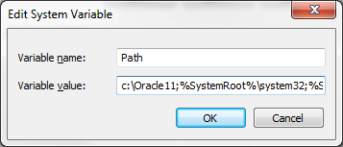
Click the ‘New’ button to create a new system variable
Enter ‘tns_admin’ in the ‘Variable name’ field and ‘c:\Oracle11’ in the ‘Variable value’ field
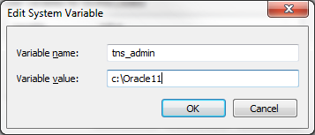
Click ‘OK’ to save it and ‘OK’ until you are back to the ‘Computer Properties’ window
Close the window and restart your computer

Installing Golden
Double Click the file named ‘goldensetup57460.exe’
Follow the prompts and choose all of the default settings
Once Golden is setup it will create the following folder in your program list
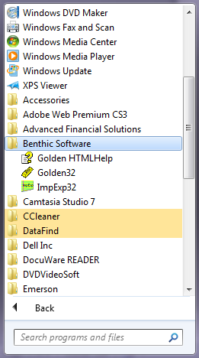
Setting OCI.DLL Parameter in Golden

Open GOLDEN
At the logon window click the ‘Options’ button
(Note: If you can’t see the Options button click the ‘More’ button to display it.)
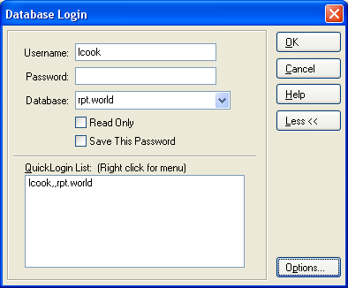

In the ‘OCI DLL Name:’ box enter the following string: ‘C:\Oracle11\instantclient_11_2\oci.dll’
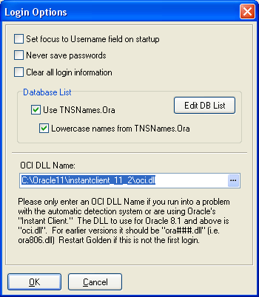

Click ‘OK’

Logon to Golden
Enter your ‘Username’, ‘Password’ , and ’rpt.world’ in the ‘Database’ box.
(Note: The first time you open Golden the ‘Database’ box will be empty.)
Click ‘OK’ to logon

